Corvette Cruisers of Illinois ~ Newsletter June 2018

The June meeting came to order at 6:04 pm, Thursday June 14, 2018 at the Beef House.
Before the meeting actually we had a visitor from the Catlin Illinois Lions Club – Dave Dutton come and spoke to us about an upcoming car show they will be having in September. They would like to invite the Corvette Cruisers to come and participate. Flyer information will follow.
Meeting opened with the reading of the May minutes. The minutes were approved.

The Treasury report was read by Deb and approved.

VP- Dave is awaiting more information- soon as he gets the number of cars needed- emails will go out. Be looking & ready …..

Governor’s Report- No meeting in June- but have found that the 2019 NCCC Convention is being held in Colorado. If you are interested in going mark on your calendar July 7 – July 12. We have a year to plan and save our pennies for it.

Upcoming events:

June-

6.23 Bloomington Gold- for those that are planning to go Saturday 6.23, we are meeting at the Indiana rest area by 7:20 am and pulling out at 7:30 am. Please remember tickets & wrist bands. We will stop for breakfast- then straight over to the track. Tickets are still available please call Bloomington Gold if you find you can attend.

July-

7.7 Ride for PTSD – see the attached flyer. Registration starts at 10:00am. If you are going to participate meeting at Custard Cup parking lot at 9:45 to caravan over to the American Legion.

7.22 Club Event- Cruising to the Veterans- Remember we need everyone’s help with this event. At the July meeting we will need you to stick around after the meeting to help stuff goodie bags. We have 100 bags to fill with misc items. Dash plaques have been ordered and received. The first 100 cars will get a dash plaque. We didn’t budget for any dash plaques - but if you would like to donate to the plaques please see Don. Times to meet for the event will be talked about at the July meeting.

August

8.11 Cheeseburger & Fun- see the attached flyer.

8.12-8.16 Gatlinburg- if you are going and would like to drive to Biltmore Estates in Asheville, NC – please let Marianne know as soon as possible. Need 10 to go to get group tickets.

8.25 Vettes on the River- if you are planning on going you will need to get online and purchase your pass as soon as possible. The pass to get into the car show is emailed to you- you will need to print that off and carry that to the event to get in. As of now, several are staying at the Isle of Capri Hotel/Casino. There are other hotels in the area. Hurry and get signed up ….the American Picker store is close to this event.

September

This is the month we will be hit with Parades & more Parades.

9.21-9.23 17th Annual International Route 66 Mother Road Car show- Please see the attached flyer.
9.20-23 Fun Fest at Mid America

This year The Sparlings are going to attend both events. The plans ….if you would like to do both are:

Thursday 9.20 Attend the Fun Run Road Tour in Effingham
Friday 9.21 Drive to Springfield get in line for the Cruise on Route 66.
Saturday – Mid morning or early afternoon head to Effingham for the fun & Festivities.

Fun Fest this year is “FREE” but you still need to call or get on line and be signed up.

June- 17th Ron
24th Carol
28th Lyndall

July Birthday’s
12th Bill 19th Gary 23rd Clint 28th Tom

Beef House Dinner Theatre – if you are interested call Karen G.
July 6, 7, 8*, 26*, 27, 28, 29*,
August 1*, 2*, 3, 4 & 5*

$48 per person

Back after a sold out run in 2016, Million Dollar Quartet will feature nearly all of our original cast including LOGAN KIRBY as Johnny Cash & DALTON HALLS as Carl Perkins. This favorite is set on December 4, 1956 when an extraordinary twist of fate brought JOHNNY CASH, JERRY LEE LEWIS, CARL PERKINS & ELVIS PRESLEY together at Sun Records in Memphis for what would be one of the greatest jam sessions ever, under the watchful eye of the Father of Rock n Roll, Same Phjillips (portrayed once again by Robert Scott). M$Q brings that legendary December night to life with an irresistable tale of broken promises, secrets, betrayal and celebrations that is both poignant and funny. Relive the era with the smash-hit sensation featuring "Blue Suede Shoes", "Fever", "Walk the Line", "Sixteen Tons", "Who Do You Love", "Great Balls of Fire", "Folsom Prison Blues", "Whole Lotta Shakin' Goin' On" and "Hound Dog".
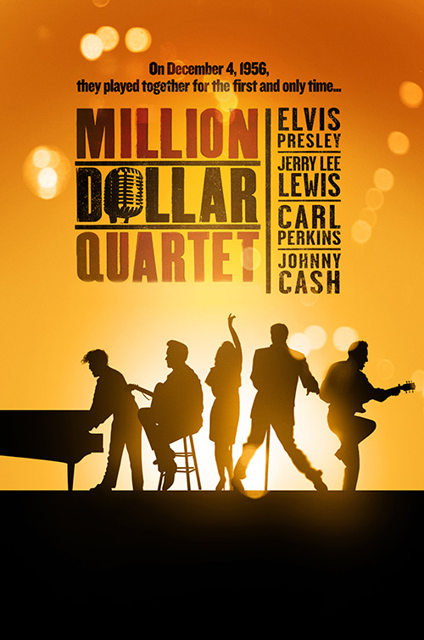

50/50 Ticket winner was Pat
July meeting is set for July 12th at the Beef House at 6:00.

Meeting adjourned at 6:45

Club Shirts- black & red. If you would like to order a shirt – please let Deb know. Since payment needs to be included with the order-, you will need to pay for the shirt upfront. Please send a check to Deb.

If you have any corrections or would like to add anything to the newsletter, please let me know.
Thanks,
Judie

