Corvette Cruisers of Illinois ~ Newsletter September 2018

The September meeting came to order at 6:37 pm, Thursday September 13, 2018 at the Danville Country Club. We had 29 members present.
Meeting opened with the reading of the August minutes. The minutes were approved.

The Treasury report was read by Deb and approved.

VP-Dave started rattling off all these parades that needed Corvettes.

9-14 Hoopeston Home Coming- 5 cars needed
9-16 Attica Heritage Parade- 8 cars needed - Parade starts at 2:00 Indiana time. Meeting at the Patriot Mart at 12:45 Indiana time. Illinois car meeting at 11:15 Bismarck Grade School.
9-28 Covington Home Coming Parade – 3 cars needed – meet at Casey’s in Covington at 4:15 Indiana time.
9-28 Westville Home Coming Parade- 9 cars needed – meet at County Market South by 6:30 to caravan to school.
10-12 Danville High School – Home Coming

He also received an email asking for several cars to carry in several towns in Champaign County. It was suggested to have him contact that person and have them get a hold of the Champaign Corvette Club.

**Remember if you are able to help reply back to Dave’s email ASAP**

Governor’s Report- Don attended August meeting. NCCC membership is up and showing a profit in some of the racing events. The dues are due and need to be paid as soon as possible. Our payment needs to be in their hands by October 25th or sooner. Next meeting is set for November in St. Louis.

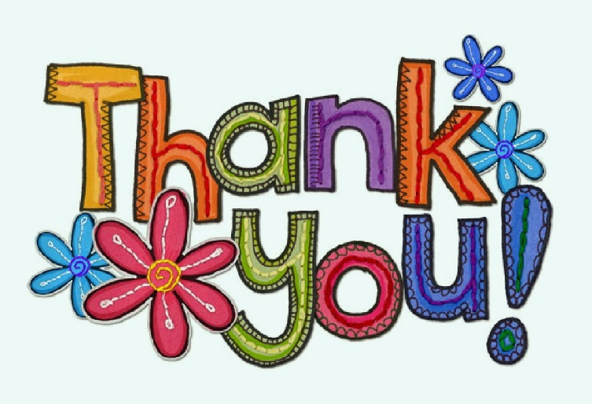

Goes out to the Monson’s. Another fun filled trip to Gatlinburg in the books. We all had a wonderful time definitely….. Lots of fun & laughter. Looking forward to next year!

Goes out to the Star City Corvette Club! They brought over 13 cars to help us out with the Hoopeston Sweet Corn Labor Day Parade. We all ended the day with a nice ride to the Family Table Restaurant in Watseka.

Ron & Pat S.- Thanks for another awesome cookout after the Westville Labor Day Parade. Pat your Pies are amazing!!!

**Ron wanted to let us all know any hot dogs, buns & chips left over – they took to the Danville Mission.
AND from the Ellis’ “A BIG Thank you” to the Millers & Davenports! Thank you guys for staying with us until we had a ride home. Another Flat tire…… Thanks to Dick Hay for loaning us that spare tire to get our girl home from Watseka. It sure was a rough weekend! But you all helped us out a bunch!
Thanks!!!!!

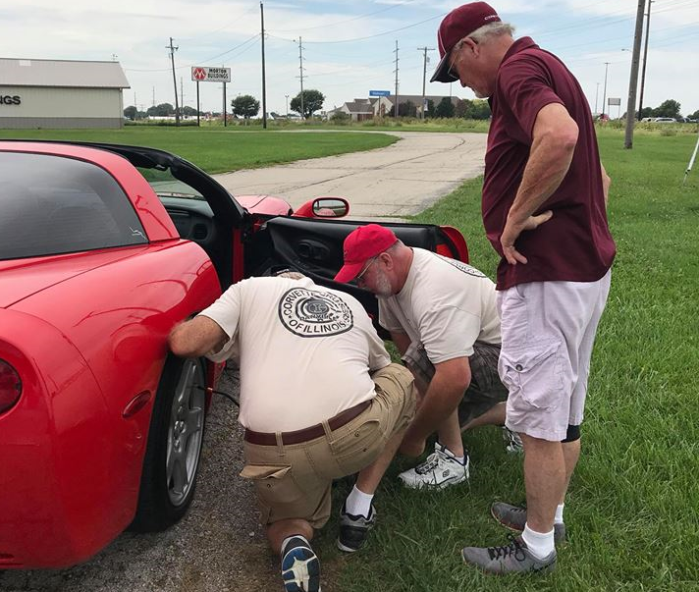

Upcoming events:

September

9/20 - Fun Fest Mid America Parade- few of us are meeting Thursday and heading down to attend the parade. If you are interested in going please call Ron for meeting place and time.

9/21 - 17th Annual International Route 66 Mother Road Car show- if you are interested in following us over to Springfield…please call Don or Judie for details. We are meeting at Boomerangs in Urbana for lunch then heading over to meet Sparling’s.

9.22 - Fun Fest at Mid America - Event is free but you need to still call and sign up. If you would like to caravan down to Effingham a group is meeting at County Market South – Saturday 9/22 - at 8:00 am sharp. They are going to the Twisted Piston for Breakfast and heading down for the day. Both groups will be together for dinner & evening entertainment.

9/28 - Covington Home Coming Parade need 3 cars – covered
Westville Home Coming- still need 1 car- if you can help out please call Dave now.

October

10/7 – Corvette Indy Poker Run- More info to follow

10/12 – Danville High School Home Coming- need 6 more cars. Please call Dave ASAP if you can help.

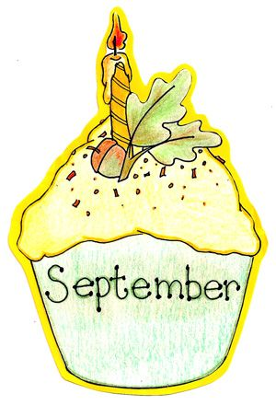

9/23 John G

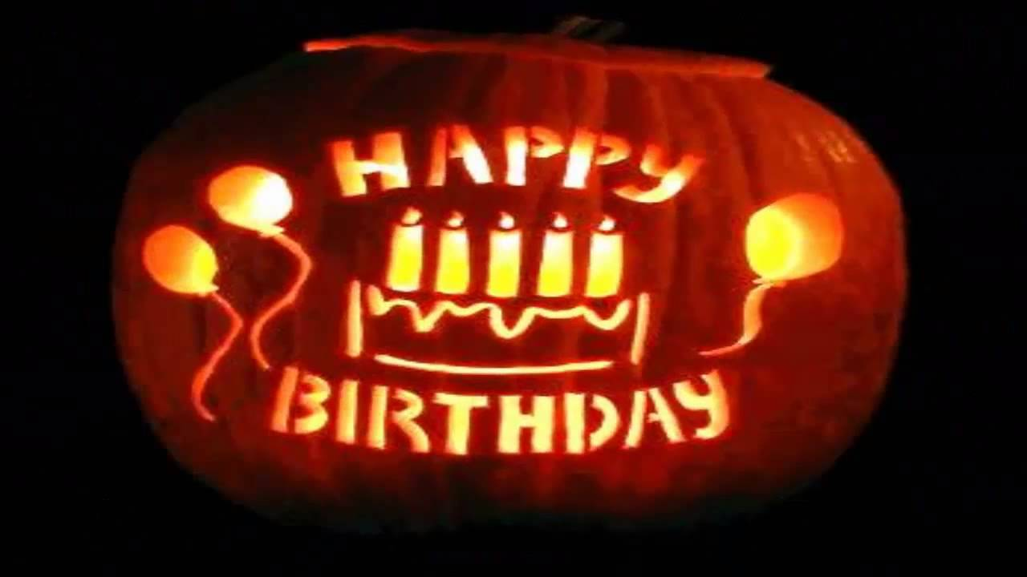

10/01 Marianne M
10/09 Karen G
10/15 Kathy H
10/19 Paul H
10/25 Judy T
10/28 Pat S
Budget Committee- it’s that time again! We have the following members on the committee-

Tom F
Jamie W
Andy M
Kathy H

Meeting October 24th, 6:30 at The Monson’s house.

Reminder:
Club dues are as follows~
Single membership $20
Couple membership $40

NCCC Dues are as follows~
New Membership Driver $35 & Companion $10
Nenewal Driver $25 & Companion $10

50/50 Ticket winner was Georgianna

October meeting is set for 10/11 at the Danville County Club at 6:30.

Meeting adjourned at 7:13
Club Shirts- black & red. If you would like to order a shirt – please let Deb know. Since payment needs to be included with the order-, you will need to pay for the shirt upfront. Please send a check to Deb.
If you have any corrections or would like to add anything to the newsletter, please let me know.
Thanks,
Judie

